Changelog
24 Apr 2018

Fixes
- The file menu’s MultiEvaluate function now generates the summary file, similar to when it’s accessed via the command line.

- Added Filename_compiler and Result_compiler to the file menu.

13 Dec 2017

Fixes

- Fixed bug for when the fly has more than 4 feet ON in the same frame.

31 Oct 2017

Fixes
- The stability ratio is now computed as represented bellow:
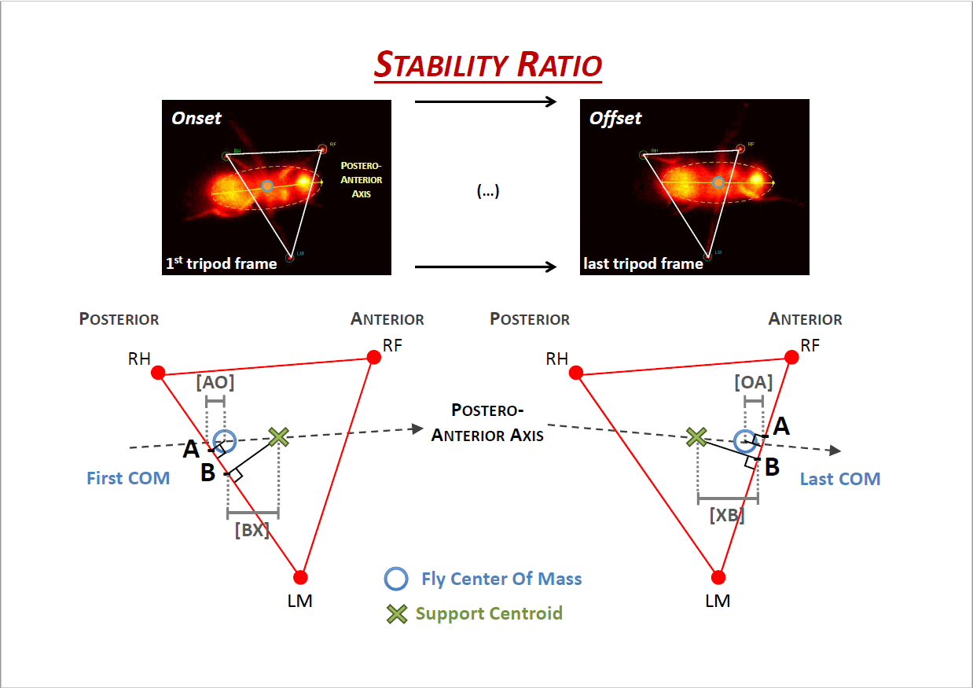

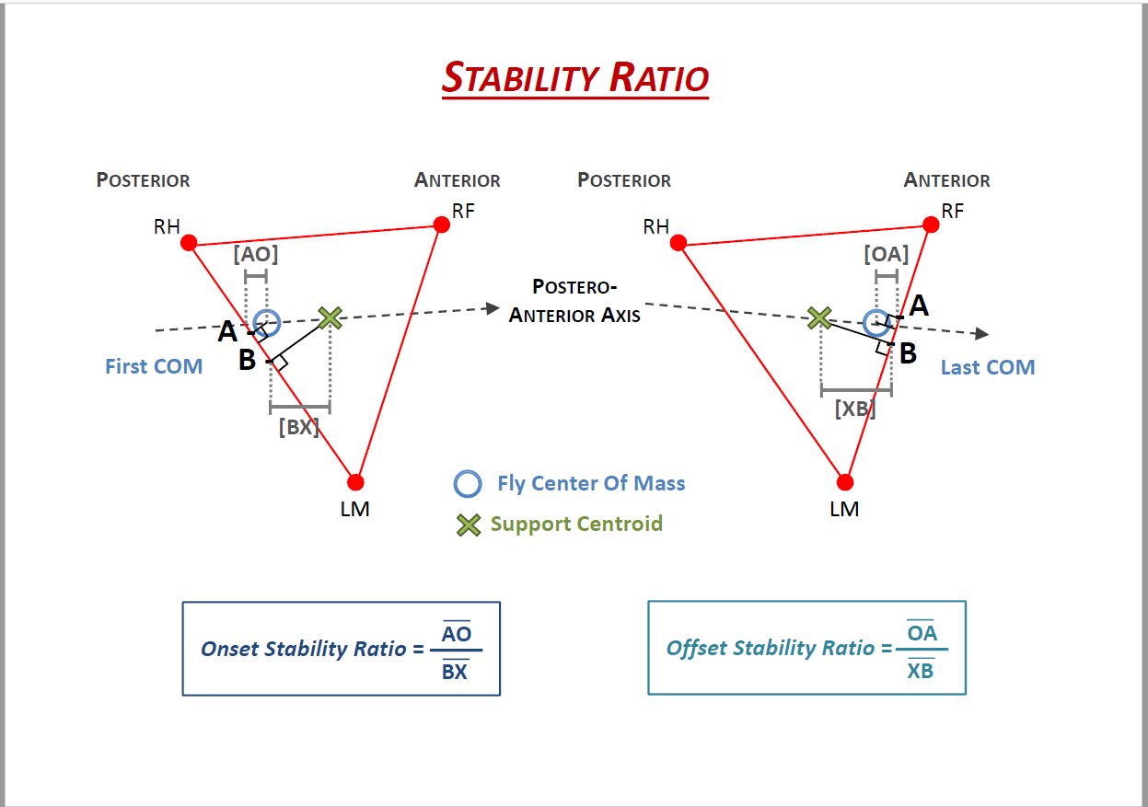
- For the frames in between the first and last, the reference side is the one closer to the Fly’s COM (Center of Mass).

30 Sep 2017

Fixes
- Fixed MultiEvaluate.m script.

- Fixed quad variable names in “1.Info_sheet”:

  - “trip index” → “pace index” (cell C40);

  - “tetrapod index” → “trot index” (cell D40);

  - “wave index” → “walk index” (CX40).

23 Sep 2017

Fixes
- Hexa or Quad versions of the software are now accessible through the File menu, instead of the Settings menu.

- Changed the title of the triangles plot to “Gait Configurations”.

- Added legend to the trajectory plot.

- Changed the 19th tab’s name to "19.Body_Track_Straightness".

- Changed the “StepStartRelativePosition” plot’s name to "Step AEP".

- Fixed multi-evaluate error.

- Fixed “4feeton” output.

- Regarding the “Triangles” sheet and plot:

  - Fixed leg legend.

  - Metrics are now calculated for every analyzed frame.

  - Added post processing code: sequences with less than 3 frames are deleted from both the plot and spreadsheet (i.e., replaced with “No data” cells).

  - Added column indicating the number of points of contact of each sequence.

  - Added the requested outputs: “Stability index”, “Average stability ratio”, “Average area of all 3-point contacts”, “Average area of all 4-point contacts”, “Average area of all configurations”.

- Added outputs from tabs 19 and 20 to the info sheet.

11 Sep 2017

Fixes
- FlyWalker_Hexa and FlyWalker_Quad are now merged into one single version of the software, FlyWalker_Hexa+Quad. In order to access either version, users must select “H” or “Q” under the Settings menu, before pressing “Evaluate”. Other software functions were not affected by this fusion.

- Renamed the “Displacement ratio” outputs in the .xls output file to “Displacement” and “Total path”.

- The .png file containing the plotted trajectory now shows the same scale on the $x$ and $y$ axis.

- Regarding the “Triangles” sheet and stability ratio output:

  - It can now assume positive values between 0 and 1, with 1 indicating the most stable situation, and negative values, indicating that the fly is unstable (the lower the ratio, the more unstable the fly is);

  - It is only computed for the first and last frames of each sequence of polygon. This is also used to compute the average onset and average offset ratios.

  - All of the computed distances and polygon areas are now computed in BodyUnits and BodyUnits², respectively.

- Renamed the triangles plot to “Tripod Stability” (where it previously shown the video path).

- Reinstated the “Stance Traces” output.

Extra buttons
- TF button (shortcut ‘l’): similar in function to the TC button, only for the front of the fly, allowing users to change the front without tampering with the back end or centroid.

Jul-Aug 2017

Fixes
- “Center to front dist” can now be changed without affecting the ellipse's position.

- “EvaluateFlyTable” now uses ActiveX instead of xlswrite, improving evaluation speed by ~60%.

Extra buttons
- TC button (shortcut 'o'): allows user to change the centroid of the fly without tampering with the ellipse (it is recommended that the user presses the 'Save' button after doing so).

Added outputs
- Displacement ratio: extra Excel sheet containing data regarding the centroid's displacement over the fly's path, as well as a .png file with the plotted trajectory and the line connecting the start and finish positions.

- Triangles: extra Excel sheet containing data regarding the plotted polygons: 'State' ('Stable' or 'Unstable'), 'Stability ratio' (the fly is the most stable when this value is the lowest – outdated, see fixes from September 2017) and 'Polygon Area'. Furthermore, if the fly is 'Unstable' at a given frame, the plotted centroid will now be colored red.

Added by Alexandre Carreira.
For more information, please contact me at:
alex.s.carreira@gmail.com

